## Introduction

The e2gen Cash Management is fully integrated into the e2gen product and provides an organisation with the ability to calculate the following:

* External correspondent (Nostro) Account Positionsfor up to 10 days forward
* Internal Account Positions for up to 10 days’ forward
* Entity based currency positions for up to 10 days’ forward

As part of the system, parameters can be defined that will allow account transfers to be automatically calculated and initiated within the back office system with full settlement message generation.

The system is flexible in being able to be configured to automatically calculate positions for multiple user defined requirements (e.g. movements, FX/MM Trades, Securities Trades etc). This is controlled via the registering of the appropriate objects within the e2gen system that interrogate all core systems and obtain information regarding account movements for the next 10 days forward.

## The Process

The e2gen Cash Management facility works on the following principles.

Obtain an accounts start of day balance from either the back office system account balance or your Nostro Statement that is received today. The latter is achieved by obtaining the Closing Available Balance (:64:) on the appropriate SWIFT MT940 or MT950 message.

The solution analyses the movements and provides a forward position analysis. Some accounts may have a value in the ‘Position Days’ field that indicates that the currency will be settled forward rather than same day. This would typically be the case for say external JPY accounts where settlement would be 2 working days forward say from a European organisation.

This position may, if required, have a minimum balance that also has to be factored in to the calculation of the position. Depending on whether the account is overdrawn or in credit, funds can either be swept into or from the account being analysed. The sweep can either be performed manually or specified to occur automatically at a certain time during the day as shown below.



## Core System Checking

The system will, where possible check the following within the institution’s core system.

* That the client numbers exist.
* That the account numbers exist in the appropriate currency
* The client and account numbers are not closed
* The client and account numbers are not blocked

## Calculating the Transfer Required

The system will apply the following calculation of the value of the transfer Required.

**Transfer = External - Minimum + The Sum of Movements + Manual Adjustments**

**Required Position Balance to the Positions Date**

Where

* **External Position** is the value of the account’s start of day balance from either the core system or the ‘Closing Available Balance (:64:) from the SWIFT statements.
* **Minimum Balance** is defined by the Cash Management Accounts static data.
* **Positions Date** is defined by the position days on the account. (e.g. 0=Today, 1=1day forward etc)

# Cash Management Accounts

## General

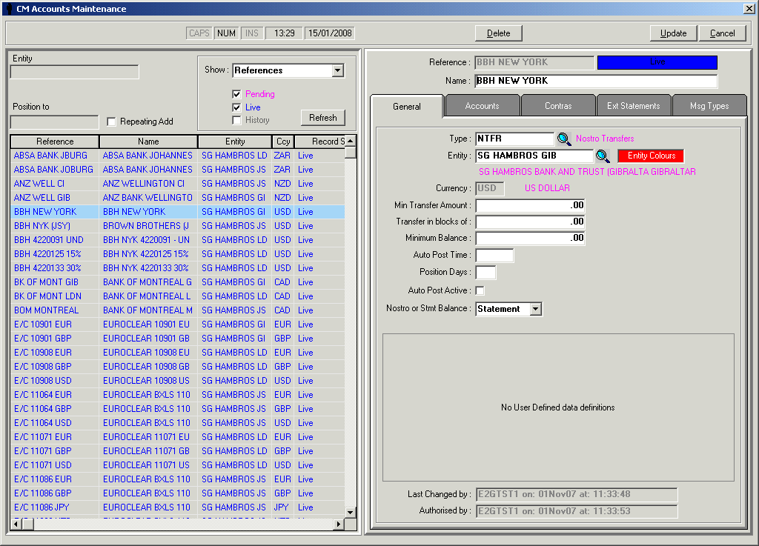

|  |  |
| --- | --- |
| **Field** | **Meaning** |
| **Reference** | This is the unique reference name that you wish to assign to an account |
| **Name** | This is a long name description for the account |
| **Type** | The types that are available control the ability to perform external transfers and cross currency transfers. |
| **Entity** | This is the counterparty reference of the entity. |
| **Currency** | This is the ISO currency code of the SWIFT statement and back office system accounts that are to be defined. |
| **Min Transfer Amount** | This is the minimum transfer amount that should be made. |
| **Minimum Balance** | This is the minimum balance that must be maintained on the Nostro account. |
| **Auto Post Time** | This is the time that an automatic sweep should take place. |
| **Position Days** | This is used to calculate the value date of entries that have been input today to be accumulated for the sum of the ‘Daily Movements’ that will be used to calculate the transfer required.  E.g  0=Today  1=Next working day etc. |
| **Auto Post Active** | This field must be ticked to enable an automated sweep the be specified. |
| **Nostro or Statement Balance** | This determines whether positions are calculated using back office system account or SWIFT statement balances. |

Accounts

The accounts specified here are the accounts that the transfer amounts are calculated on.

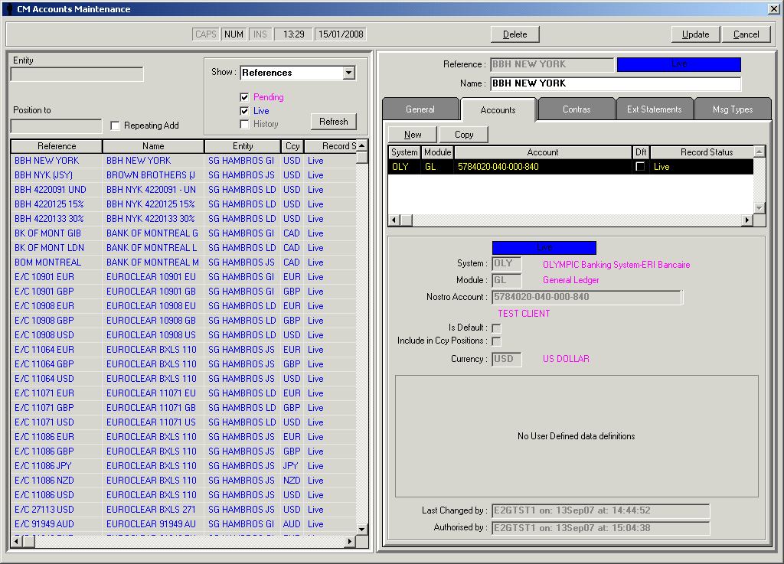

|  |  |
| --- | --- |
| **Field** | **Meaning** |
| **System** | This is the registered system code of the back office system that is the source for the account movements that are used in the Cash Management analysis |
| **Module** | This is the registered module code linked to the system code of the back office system that is the source for the account movements that are used in the Cash Management analysis |
| **Nostro Account Number** | This is the back office system nostro account whose daily movements are to be included for the Cash Management analysis. |
| **Is Default** | This specifies the default nostro account that funds are transferred into or out of. This is only required if multiple accounts are specified. |
| **Currency** | This is the ISO currency code of the accounts defined. |

## Contras

The accounts specified here are the accounts that the transfer amounts are transferred from/to in order to maintain the correct position for the accounts on the ‘Accounts’ tab.

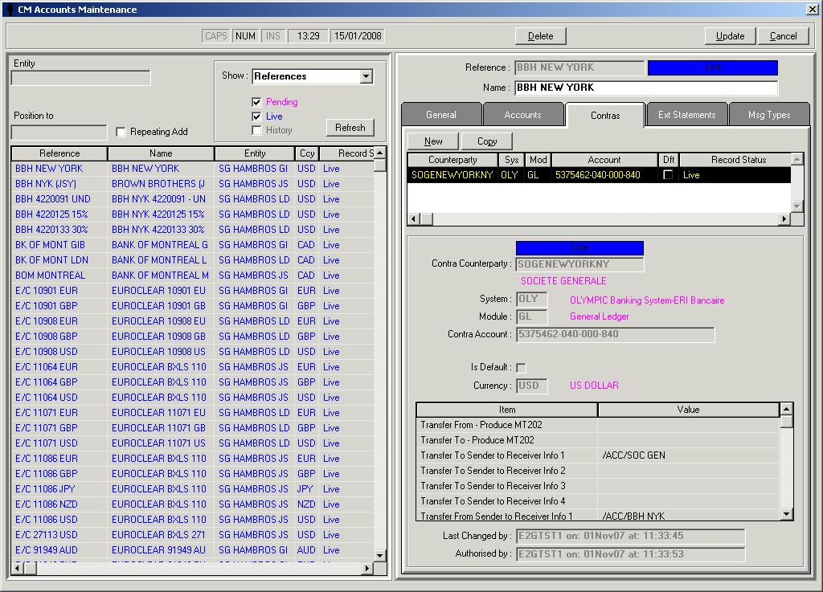

|  |  |
| --- | --- |
| **Field** | **Meaning** |
| **System** | This is the registered system code of the back office system that is the source for the account movements that are used in the Cash Management analysis |
| **Module** | This is the registered module code linked to the system code of the back office system that is the source for the account movements that are used in the Cash Management analysis |
| **Contra Account** | This is the back office system account that funds are transferred from to maintain the correct account positions. |
| **Is Default** | This specifies the default nostro account that funds are transferred into or out of. This is only required if multiple accounts are specified. |
| **Currency** | This is the ISO currency code of the accounts defined. |
| **Transfer From – Produce MT202** | This specified whether an MT202 rather than an MT200 is produced |
| **Transfer To – Produce MT202** | This specified whether an MT202 rather than an MT200 is produced |
| **Transfer To Sender to Receiver Info 1 – 4** | This is used to default the value of the ‘Sender to Receiver’ (:72) field when transferring funds into the account monitored. |
| **Transfer From Sender to Receiver Info 1 – 4** | This is used to default the value of the ‘Sender to Receiver’ (:72) field when transferring funds from the account monitored. |

## External Statements

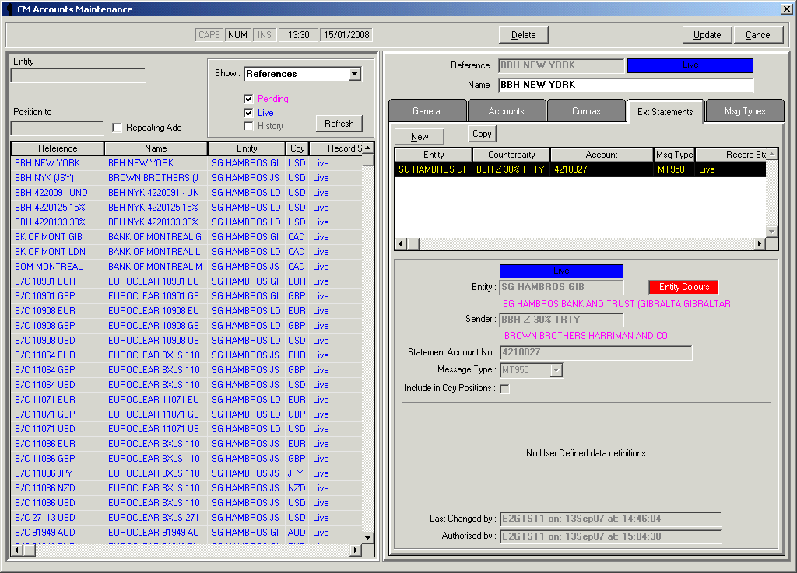

| **Field** | **Meaning** |
| --- | --- |
| **Entity** | This is the counterparty reference of the entity of the receiving SWIFT message that will be defined for the external SWIFT statement. |
| **Sender** | This is the counterparty reference of the sender of the SWIFT statement message. |
| **Statement Account Number** | This is the value of the SWIFT statement account number (:25:). |
| **Message Type** | This is the message type of the SWIFT statement.  This must contain either ‘MT940’ , ‘MT950’ or left blank for either. |
| **Include in Ccy Positions** | This determines whether the statement details are to be included in currency positions or not. |
| **Module** | This is the registered module code linked to the system code of the back office system that is the source for the account movements that are used in the Cash Management analysis |
| **Nostro Account Number** | This is the back office system nostro account whose daily movements are to be included for the Cash Management analysis. |
| **Contra Counterparty 1** | This is the counterparty reference of the bank’s nostro correspondent that will be used for sweeping the nostro account balances to the minimum balance.  This counterparty will be the SWIFT counterparty for any MT2* payment/receipt messages that need to be generated. |
| **Contra Account Number 1** | This is the contra account number to the specified nostro account that will be used for sweeping the nostro account to the appropriate minimum balance. |
| **Contra Counterparty 2** | This is an optional alternate counterparty reference of the bank’s nostro correspondent that will be used for sweeping the nostro account balances to the minimum balance.  This counterparty will be the SWIFT counterparty for any MT2* payment/receipt messages that need to be generated. |
| **Contra Account Number 2** | This is an optional alternate contra account number to the specified nostro account that will be used for sweeping the nostro account to the appropriate minimum balance. |
| **Intraday Limit** | This is the limit above which an automatic transfer will be required to be created. |
| **Minimum Balance** | This is the minimum balance that must be maintained on the Nostro account. |
| **Auto Post Time** | This is the time that an automatic sweep should take place. |
| **Auto Post Active** | This field must be ticked to enable an automated sweep the be specified. |
| **Position Days** | This is used to calculate the value date of entries that have been input today to be accumulated for the sum of the ‘Daily Movements’ that will be used to calculate the transfer required.  E.g  0=Today  1=Next working day etc |

## Message types

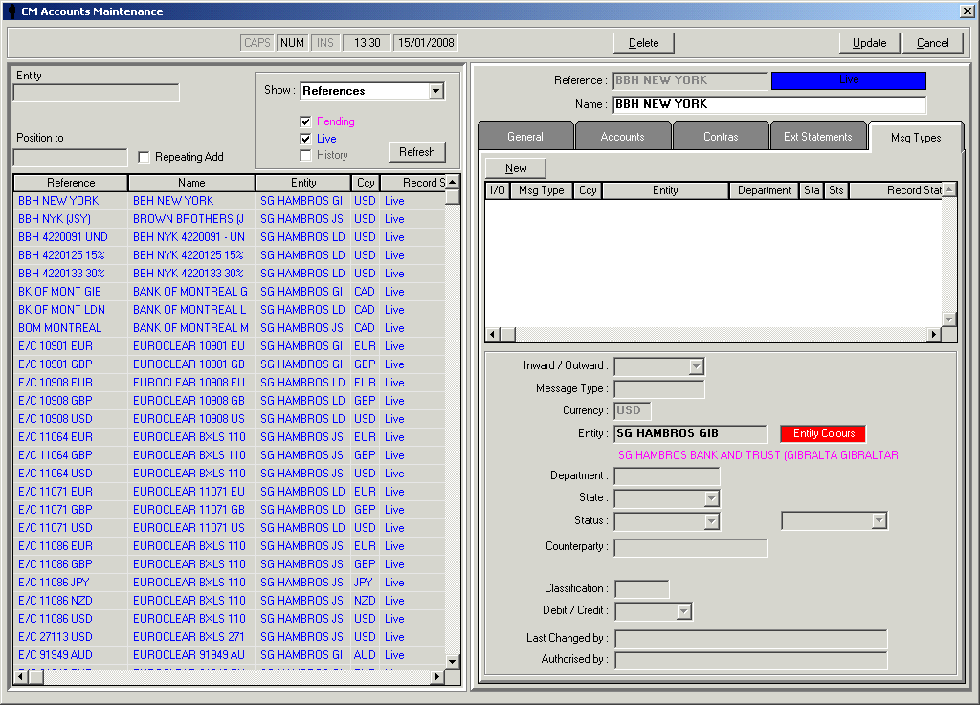

The following fields will need to be defined:

|  |  |
| --- | --- |
| **Field** | **Meaning** |
| **Inward / Outward** | This determines if the message types to include are inward or outward messages |
| **Message Type** | This defines the message type |
| **Currency** | This is the ISO currency code of the SWIFT statement and back office system accounts that are to be defined. |
| **Entity** | This is the entity of the message |
| **Department** | This is the department of the message |
| **State** | This is the message state |
| **Status** | This is the message status |
| **Counterparty** | This is the sender/receiver of the message being received/sent. |
| **Classification** | This is the classification of the message |
| **Debit/Credit** | This defines whether the message should be treated as a debit or credit adjustment. |

# Manual Adjustments

The ability to specify manual adjustments for any account is possible these adjustments can be given either a credit or debit adjustment amount as well as a value date.

When the adjustments are created they can be given the following ‘End of Day action’:

* Keep during end of day. These adjustments will need to be manually deleted.
* Clear during end of day. These adjustments are automatically deleted during the next end of day process.

The typical screen is shown below.

